**UNIVERSIDAD DE SAN CARLOS DE GUATEMALA**

**CENTRO UNIVERSITARIO DE OCCIDENTE**

**ANALIZADOR SINTÁCTICO**

**DEFINICIÓN FORMAL**

G = ( N, T, P, S)

|  |  |
| --- | --- |
| N | * E * F * Y * _Y * G * Pa * Pc * A * P * _L * V * K * Q * K’ * _K * _K’ * S * _S * O * O’ * M * _M * R * H * _H * Z * T * _W * W * _P * C * D * X * B * _B * U * _U * I * I’ * J * L * _Ñ * _Q * Fe |
| T | * **Entero** * **Cadena** * **Chart** * **Decimal** * **Boolean** * **SI** * **SINO_SI** * **SINO** * **MIENTRAS** * **HACER** * **DESDE** * **HASTA** * **INCREMENTO** * **Imprimir** * **Leer** * **(** * **)** * **{** * **}** * **palabra** * **entero** * **string** * **char** * **decimal** * **True** * **False** * **Variable** * **=** * **==** * **,** * **;** * **+** * **++** * **-** * **--** * **>** * **>=** * **<** * **<=** * **¡** * **¡=** * **&&** * **||** |
| S | E |
| P |  |

P

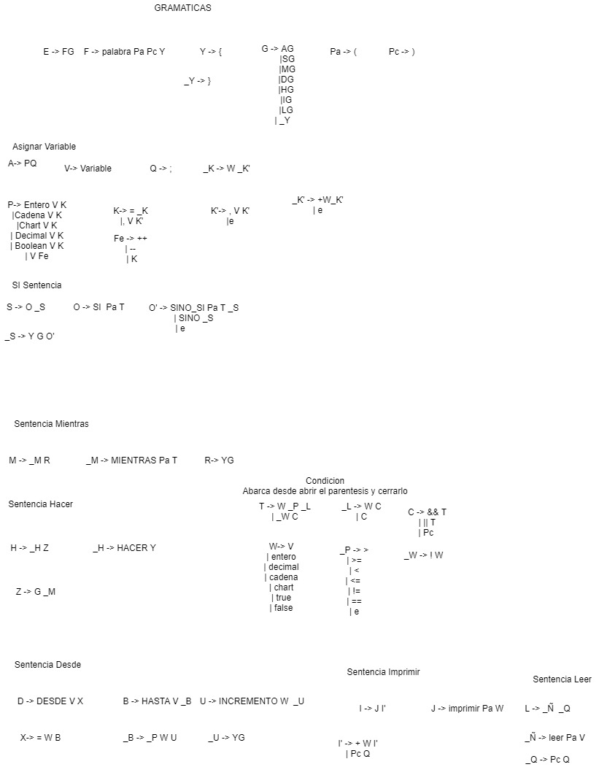

**Cálculo de Primeros**



**Cálculo de Siguientes**



**Tabla de Transiciones**

|  |  |  |  |  |  |  |  |  |  |  |  |  |  |  |  |  |  |  |  |  |  |  |  |  |  |  |  |  |  |  |  |  |  |  |  |  |  |  |  |  |  |  |  |  |
| --- | --- | --- | --- | --- | --- | --- | --- | --- | --- | --- | --- | --- | --- | --- | --- | --- | --- | --- | --- | --- | --- | --- | --- | --- | --- | --- | --- | --- | --- | --- | --- | --- | --- | --- | --- | --- | --- | --- | --- | --- | --- | --- | --- | --- |
|  |  | Entero | Cadena | Chart | Decimal | Boolean | SI | SINO_SI | SINO | MIENTRAS | HACER | DESDE | HASTA | INCREMENTO | IMPRIMIR | LEER | { | } | ( | ) | Palabra | entero | string | char' | decimal | true | false | variable | = | == | , | ; | + | > | >= | < | <= | ! | ! = | && | || | ++ | -- | $ |
| 1 | E |  |  |  |  |  |  |  |  |  |  |  |  |  |  |  |  |  |  |  | FG |  |  |  |  |  |  |  |  |  |  |  |  |  |  |  |  |  |  |  |  |  |  |  |
| 2 | F |  |  |  |  |  |  |  |  |  |  |  |  |  |  |  |  |  |  |  | Palabra Pa Pc Y |  |  |  |  |  |  |  |  |  |  |  |  |  |  |  |  |  |  |  |  |  |  |  |
| 3 | Y |  |  |  |  |  |  |  |  |  |  |  |  |  |  |  | { |  |  |  |  |  |  |  |  |  |  |  |  |  |  |  |  |  |  |  |  |  |  |  |  |  |  |  |
| 4 | _Y |  |  |  |  |  |  |  |  |  |  |  |  |  |  |  |  | } |  |  |  |  |  |  |  |  |  |  |  |  |  |  |  |  |  |  |  |  |  |  |  |  |  |  |
| 5 | G | AG | AG | AG | AG | AG | SG |  |  | MG | HG | DG |  |  | IG | LG |  | _Y |  |  |  |  |  |  |  |  |  | A G |  |  |  |  |  |  |  |  |  |  |  |  |  |  |  |  |
| 6 | Pa |  |  |  |  |  |  |  |  |  |  |  |  |  |  |  |  |  | ( |  |  |  |  |  |  |  |  |  |  |  |  |  |  |  |  |  |  |  |  |  |  |  |  |  |
| 7 | Pc |  |  |  |  |  |  |  |  |  |  |  |  |  |  |  |  |  |  | ) |  |  |  |  |  |  |  |  |  |  |  |  |  |  |  |  |  |  |  |  |  |  |  |  |
| 8 | A | PQ | PQ | PQ | PQ | PQ |  |  |  |  |  |  |  |  |  |  |  |  |  |  |  |  |  |  |  |  |  | P Q |  |  |  |  |  |  |  |  |  |  |  |  |  |  |  |  |
| 9 | P | Entero VK | Cadena VK | Chart VK | Decimal VK | Boolean VK |  |  |  |  |  |  |  |  |  |  |  |  |  |  |  |  |  |  |  |  |  | V Fe |  |  |  |  |  |  |  |  |  |  |  |  |  |  |  |  |
| 10 | _L |  |  |  |  |  |  |  |  |  |  |  |  |  |  |  |  |  |  | C |  | WC | WC | WC | WC | WC | WC | WC |  |  |  |  |  |  |  |  |  |  |  | C | C |  |  |  |
| 11 | V |  |  |  |  |  |  |  |  |  |  |  |  |  |  |  |  |  |  |  |  |  |  |  |  |  |  | Variable |  |  |  |  |  |  |  |  |  |  |  |  |  |  |  |  |
| 12 | K |  |  |  |  |  |  |  |  |  |  |  |  |  |  |  |  |  |  |  |  |  |  |  |  |  |  |  | =_K |  | ,V K' |  |  |  |  |  |  |  |  |  |  |  |  |  |
| 13 | Q |  |  |  |  |  |  |  |  |  |  |  |  |  |  |  |  |  |  |  |  |  |  |  |  |  |  |  |  |  |  | ; |  |  |  |  |  |  |  |  |  |  |  |  |
| 14 | K' |  |  |  |  |  |  |  |  |  |  |  |  |  |  |  |  |  |  |  |  |  |  |  |  |  |  |  |  |  | ,V K' | e |  |  |  |  |  |  |  |  |  |  |  |  |
| 15 | _K |  |  |  |  |  |  |  |  |  |  |  |  |  |  |  |  |  |  |  |  | W _K' | W _K' | W _K' | W _K' | W _K' | W _K' | W _K' |  |  |  |  |  |  |  |  |  |  |  |  |  |  |  |  |
| 16 | _K' |  |  |  |  |  |  |  |  |  |  |  |  |  |  |  |  |  |  |  |  |  |  |  |  |  |  |  |  |  |  | e | + W _K' |  |  |  |  |  |  |  |  |  |  |  |
| 17 | S |  |  |  |  |  | O _S |  |  |  |  |  |  |  |  |  |  |  |  |  |  |  |  |  |  |  |  |  |  |  |  |  |  |  |  |  |  |  |  |  |  |  |  |  |
| 18 | _S |  |  |  |  |  |  |  |  |  |  |  |  |  |  |  | YGO' |  |  |  |  |  |  |  |  |  |  |  |  |  |  |  |  |  |  |  |  |  |  |  |  |  |  |  |
| 19 | O |  |  |  |  |  | SI Pa T |  |  |  |  |  |  |  |  |  |  |  |  |  |  |  |  |  |  |  |  |  |  |  |  |  |  |  |  |  |  |  |  |  |  |  |  |  |
| 20 | O' | e | e | e | e | e | e | SINO_SI Pa T_S | SINO _S | e | e | e |  |  | e | e |  | e |  |  |  |  |  |  |  |  |  |  |  |  |  |  |  |  |  |  |  |  |  |  |  |  |  |  |
| 21 | M |  |  |  |  |  |  |  |  | _M R |  |  |  |  |  |  |  |  |  |  |  |  |  |  |  |  |  |  |  |  |  |  |  |  |  |  |  |  |  |  |  |  |  |  |
| 22 | _M |  |  |  |  |  |  |  |  | MIENTRAS Pa T |  |  |  |  |  |  |  |  |  |  |  |  |  |  |  |  |  |  |  |  |  |  |  |  |  |  |  |  |  |  |  |  |  |  |
| 23 | R |  |  |  |  |  |  |  |  |  |  |  |  |  |  |  | YG |  |  |  |  |  |  |  |  |  |  |  |  |  |  |  |  |  |  |  |  |  |  |  |  |  |  |  |
| 24 | H |  |  |  |  |  |  |  |  |  | _H Z |  |  |  |  |  |  |  |  |  |  |  |  |  |  |  |  |  |  |  |  |  |  |  |  |  |  |  |  |  |  |  |  |  |
| 25 | _H |  |  |  |  |  |  |  |  |  | HACER Y |  |  |  |  |  |  |  |  |  |  |  |  |  |  |  |  |  |  |  |  |  |  |  |  |  |  |  |  |  |  |  |  |  |
| 26 | Z | G_M | G_M | G_M | G_M | G_M | G_M |  |  | G_M | G_M | G_M |  |  | G_M | G_M |  | G_M |  |  |  |  |  |  |  |  |  |  |  |  |  |  |  |  |  |  |  |  |  |  |  |  |  |  |
| 27 | T |  |  |  |  |  |  |  |  |  |  |  |  |  |  |  |  |  |  |  |  | W_P_L | W_P_L | W_P_L | W_P_L | W_P_L | W_P_L | W_P_L |  |  |  |  |  |  |  |  |  | _W C |  |  |  |  |  |  |
| 28 | _W |  |  |  |  |  |  |  |  |  |  |  |  |  |  |  |  |  |  |  |  |  |  |  |  |  |  |  |  |  |  |  |  |  |  |  |  | ! W |  |  |  |  |  |  |
| 29 | W |  |  |  |  |  |  |  |  |  |  |  |  |  |  |  |  |  |  |  |  | entero | cadena | chart | decimal | false | false | V |  |  |  |  |  |  |  |  |  |  |  |  |  |  |  |  |
| 30 | _P |  |  |  |  |  |  |  |  |  |  |  |  |  |  |  |  |  |  | e |  |  |  |  |  |  |  |  |  | == |  |  |  | > | >= | < | <= |  | != |  |  |  |  |  |
| 31 | C |  |  |  |  |  |  |  |  |  |  |  |  |  |  |  |  |  |  | Pc |  |  |  |  |  |  |  |  |  |  |  |  |  |  |  |  |  |  |  | && T | || T |  |  |  |
| 32 | D |  |  |  |  |  |  |  |  |  |  | DESDE VX |  |  |  |  |  |  |  |  |  |  |  |  |  |  |  |  |  |  |  |  |  |  |  |  |  |  |  |  |  |  |  |  |
| 33 | X |  |  |  |  |  |  |  |  |  |  |  |  |  |  |  |  |  |  |  |  |  |  |  |  |  |  |  | =W B |  |  |  |  |  |  |  |  |  |  |  |  |  |  |  |
| 34 | B |  |  |  |  |  |  |  |  |  |  |  | Hasta V _B |  |  |  |  |  |  |  |  |  |  |  |  |  |  |  |  |  |  |  |  |  |  |  |  |  |  |  |  |  |  |  |
| 35 | _B |  |  |  |  |  |  |  |  |  |  |  |  |  |  |  |  |  |  |  |  |  |  |  |  |  |  |  |  | _P W U |  |  |  | _P W U | _P W U | _P W U | _P W U |  | _P W U |  |  |  |  |  |
| 36 | U |  |  |  |  |  |  |  |  |  |  |  |  | INCREMENTO W _U |  |  |  |  |  |  |  |  |  |  |  |  |  |  |  |  |  |  |  |  |  |  |  |  |  |  |  |  |  |  |
| 37 | _U |  |  |  |  |  |  |  |  |  |  |  |  |  |  |  | Y G |  |  |  |  |  |  |  |  |  |  |  |  |  |  |  |  |  |  |  |  |  |  |  |  |  |  |  |
| 38 | I |  |  |  |  |  |  |  |  |  |  |  |  |  | J I' |  |  |  |  |  |  |  |  |  |  |  |  |  |  |  |  |  |  |  |  |  |  |  |  |  |  |  |  |  |
| 39 | I' |  |  |  |  |  |  |  |  |  |  |  |  |  |  |  |  |  |  | Pc Q |  |  |  |  |  |  |  |  |  |  |  |  | + W I' |  |  |  |  |  |  |  |  |  |  |  |
| 40 | J |  |  |  |  |  |  |  |  |  |  |  |  |  | IMPRIMIR Pa W |  |  |  |  |  |  |  |  |  |  |  |  |  |  |  |  |  |  |  |  |  |  |  |  |  |  |  |  |  |
| 41 | L |  |  |  |  |  |  |  |  |  |  |  |  |  |  | _Ñ _Q |  |  |  |  |  |  |  |  |  |  |  |  |  |  |  |  |  |  |  |  |  |  |  |  |  |  |  |  |
| 42 | _Ñ |  |  |  |  |  |  |  |  |  |  |  |  |  |  | Leer Pa V |  |  |  |  |  |  |  |  |  |  |  |  |  |  |  |  |  |  |  |  |  |  |  |  |  |  |  |  |
| 43 | _Q |  |  |  |  |  |  |  |  |  |  |  |  |  |  |  |  |  |  | Pc Q |  |  |  |  |  |  |  |  |  |  |  |  |  |  |  |  |  |  |  |  |  |  |  |  |
|  | Fe |  |  |  |  |  |  |  |  |  |  |  |  |  |  |  |  |  |  | Pc Q |  |  |  |  |  |  |  |  | K |  |  |  |  |  |  |  |  |  |  |  |  |  | ++ | -- |